 Global Business Services



**Digital Insights driven Cognitive Enterprise (DICE) Reference Architecture**

White Paper

Draft Version 0.1

2019-08-28

Ryan Chiang, Ph.D.

*Senior Solution Architect, Data Platform Service, Tiger Team, GBS Europe*

Ramesh Sigamani

*Senior Solution Architect, Data Platform Service, Tiger Team, GBS Europe*

Vijay Sharma

*IBM Partner, Data Platform Service: Practice Leader, GBS Europe*

Allan Coulter

*Distinguished Engineer - CTO for Nordic Services, GBS*

**Revision History**

|  |  |  |  |  |
| --- | --- | --- | --- | --- |
| Date | Ver | Revised By | Reviewers | Description |
| 2019-08-28 | v0.1 | Ryan |  | Draft based on DICE 1.0 |
|  |  |  |  |  |

Table of Contents

1. Introduction 4

2. Data Driven Cognitive Enterprise 4

2.1. Cognitive Enterprise 4

2.2. Why Data Driven Practice 5

2.2.1. Data is Foundation for Business 5

2.2.2. Opportunities for Technology Disruptions 5

2.3. Digital Insights driven Cognitive Enterprise 6

2.4. IBM Consolidated Operation 8

3. Business Challenges 8

3.1. Common Pain Points 8

3.2. Transformation of Enterprise Architecture 9

3.3. Extension of Business Capabilities 9

3.4. Need for DICE Reference Architecture 10

4. Journey to Data, AI and Cloud 10

4.1. Business Value Propositions with Data Journey 10

4.2. Solution Prescription 12

4.3. Combined Journey to Cloud 12

5. Architecture Principles 13

6. Reference Architecture 14

6.1. Overview 14

6.1.1. Functional Blocks 14

6.1.2. Component Architecture 15

6.2. Cloud Environment 15

6.2.1. Container based Environment 16

6.2.2. End-to-End Data Flows 16

6.2.3. Microservice and API Framework 19

6.2.4. Challenges to Clients 20

6.3. Data Foundation 20

6.4. Published API Catalog 21

6.5. DICE Microservice Hub 21

6.6. Data and AI Toolkit 22

6.7. Data Governance 22

6.8. Data Management Service 23

6.9. Cloud Native Infrastructure 23

7. Architecture Principles Explained 24

7.1. Data and Application Decoupled 24

7.2. Open Source Based 24

7.3. Single Version of Truth 24

7.4. Fit for Purpose Polyglot Storage 24

7.5. Cloud Agnostic 24

8. Component Business Model 25

9. Use Cases 25

9.1. S/4HANA and EDW Transformation 25

9.2. Intelligent Business Workflow 27

9.3. Cognitive Integration Hub 28

10. Digital Insights Method 28

11. Conclusion 29

12. References 30

# Introduction

This document describes a data driven Cognitive Enterprise reference architecture, namely, Digital Insights driven Cognitive Enterprise (DICE, pronounced as ***dice***) reference architecture, and the use cases that the architecture addresses.

# Data Driven Cognitive Enterprise

## Cognitive Enterprise

Cognitive Enterprise (Foster 2019) is defined as a next-generation business model comprising multiple business platforms that are made up of capability layers shown in Figure 1.

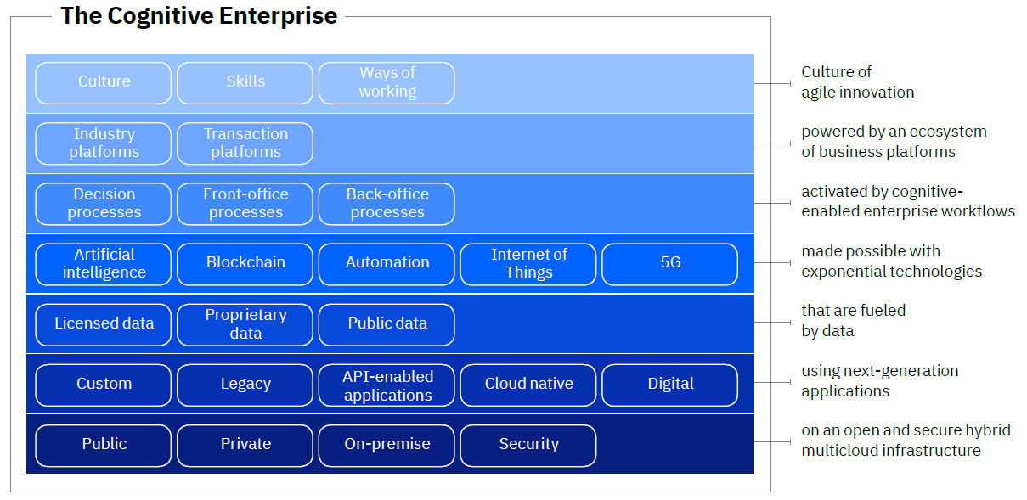

Figure Capability Layers for the Cognitive Enterprise

To create a data centric view, we re-order these capability layers to match the overall information flow and apply Cloud Native based data practices to the capability layers. The new presentation of the capability layers, as shown in Figure 2, denotes a data-driven practice perspective of Cognitive Enterprise.

Cognitive Enterprise from this perspective is defined as:

“*Intelligent business workflows enabled by skilled employees working with innovative business applications,*

*accessing outcomes from published cloud APIs,*

*enabled by a hub of microservices,*

*using data and AI toolkits powered by modern technologies,*

*processing data conformed with common data models,*

*supported by data technologies and fit-for-purpose data stores,*

*on a secure cloud native infrastructure.*”

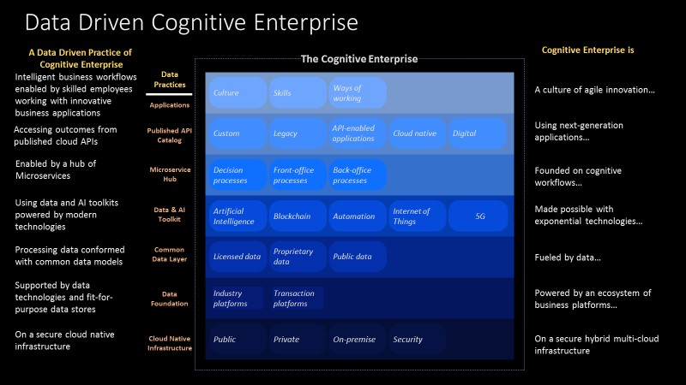

Figure Data Driven Practice of Cognitive Enterprise

## Why Data Driven Practice

### Data is Foundation for Business

Data to business is like blood to human body. Without data, the business organizations will not be functioning properly. Moreover, the data needs to be cleansed and trusted. Without trusted data, the company is not able to make sound decisions to protect it best interest.

Similarly, without data, there will not be Artificial Intelligence (AI) or Machine Learning models. The required data needs to be cleansed as well. Otherwise, the outcome of the AI or Machine Learning models will not be sensible.

A solid and trusted data foundation is a key element for a company’s success.

### Opportunities for Technology Disruptions

Many companies have realized the importance of data and strive to become data driven enterprises (Research 2018).

Moreover, experts have predicted that the data volume will be by 2025 10 folds of data in 2017. However, we are mining just 2% of data. With these figures, we are looking at a tremendous number of opportunities and disruptions in the various areas illustrated in Figure 3.



Figure Areas of opportunities and disruptions with the growing data

Therefore, leading organizations are focused on enabling a data driven “Digital Reinvention” redefining their key guiding principles, digital reinvention drivers and implementation approaches.

## Digital Insights driven Cognitive Enterprise

We name the Data Driven practice view of Cognitive Enterprise, described in Sec. 2.1, *Digital Insights driven Cognitive Enterprise* (DICE) since the data foundation will be based on IBM Digital Insights. The layers of the DICE architecture are illustrated in Figure 4.

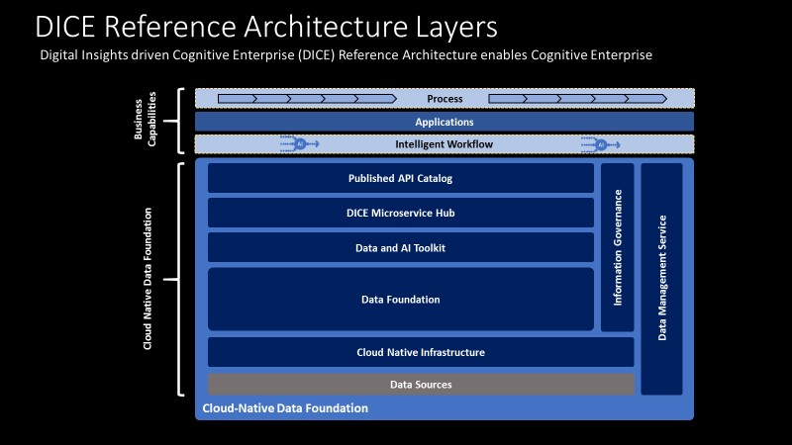

Figure DICE Reference Architecture Layers

These layers are:

**Applications**

Applications are business capabilities enabled by web applications that weaves the company processes and intelligent workflows supported by published microservices. Applications may also access services from other clouds.

The following layers constitute a ***Cloud-Native Data Foundation*** that supports for Cloud Native environment and Data Foundation.

**Published API Catalog**

Published API Catalog contains Microservices subscribed by the client. It is enabled by a common API framework that supports API management functionality such as API Gateway, API registration /discovery and load balancer.

**DICE Microservice Hub**

DICE Microservice Hub comprises all required Data & AI microservices as well as a microservice framework that supports common event ledger, monitoring, log interface, security and common utility microservices.

**Data and AI Toolkit**

This layer comprises libraries or cloud services that support various data and AI development toolkits including Machine Learning, Neural Network libraries, Blockchain and data integration and data quality tools.

**Data Foundation**

DICE Data Foundation supports a data repository and a Common Data Layer that implements Industrial Cartridges or client specific common data models. The Data Foundation and the Data & AI Toolkit layer constitute the IBM Digital Insights.

The Data Foundation establishes Single Version of Truth and supports data ingestion in batch or stream mode. It may also include (a) Polyglot Data Store(s) to address specific client requirements.

**Cloud Native Infrastructure**

This layer consists of IaaS and CaaS (Container as a Service) where CaaS is based on Docker and OpenShift /Kubernetes technology.

IaaS supports IoT hub or gateway to ingest IoT data in a streaming fashion. It also supports secure data gateway to move large volume of data between domains (data center or on-premise.)

**Data Source**

The Data Source layer includes structure, semi-structured or unstructured data from on-premise, private cloud, public clouds or IoT domain

**Information Governance**

The Information Governance layer consist of technologies and practices for Data Quality Service, Metadata Management, Lineage, Business Glossary & Taxonomy, MDM and AI Governance.

**Data Management Service**

The Data Management Service provides services for managing the Cloud-Native Data Foundation. It also supports

* shared services for DevOps DataOps, AIOps and CI/CD framework
* shared monitoring and security frameworks

## IBM Consolidated Operation

The DICE reference architecture provides a common reference architecture for three GBS practices, as illustrated in Figure 5:

* C&A Practice (Cognitive and Analytics)
* CAI Practice (Cloud Application Innovation)
* DPS Practice (Data Platform Service)

Each practice provides their services across layers where their expertise lies.



Figure IBM Consolidated Operation with DICE

# Business Challenges

## Common Pain Points

Over the past couple of years, we have seen the growing demands from our clients for cognitive application development in addition to establishing the data foundation. The driving force comes from their common pain points including

* Fast-evolving technologies
* Siloed data
* Siloed applications
* No cloud strategy
* No AI experiences
* High cost in upgrading legacy technologies
* No clear path to Digital Transformation

These pain points mostly result from the following business challenges against the movement toward a data driven enterprise:

1. Companies still have the old mentality of treating data as supportive or secondary role (Mike Rollings 2018)
2. Companies lack of the organizational focus on data and analytics (Mike Rollings 2018)
3. Companies still use legacy systems that are hard to scale or upgrade

In other words, most of the companies do not have a clear vision on their data strategy, not to mention the AI strategy.

## Transformation of Enterprise Architecture

Due to historical reasons, the technologies used by companies were adopted at different times in a leapfrog manner. These technologies, lacking compatibility with each other, integrated data from often then siloed business organizations, which led to long-lasting data silos and application silos in a company, as shown on the left side of Figure 6.

With the advance of data technologies, we have come to a point where these issues can be addressed once and for all. The right side of Figure 6 illustrates an integrated Enterprise Architecture that can be achieved with a modern cloud-based data platform with three functional layers, i.e., Infrastructure, Data Foundation and Cognitive Applications, decoupled from each other.

The full maturity of the three functional layers will enable the Digital Transformation at scale, as a result of a complete Data Value Transformation.

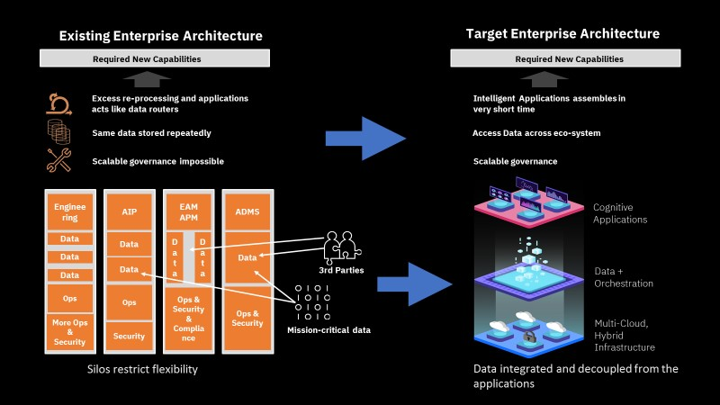

Figure 6 Transformation of Enterprise Architecture

## Extension of Business Capabilities

Using DICE platform as a common Data Foundation for all applications, we can incrementally extend or transform business capabilities (Cognitive Applications) as shown in Figure 7.

To enable a business capability, the company may initially integrate the data required for the capability. The services, implementing the data and AI processing and the business logic, required by the business capability will be containerized and deployed as microservices. These microservices will serve as glue to integrate data and cognitive capabilities, and together enable the application features.

The company may repeat the same processes to integrate new data and develop new microservices to enable the subsequent capabilities. This is basically the “as a Service” offering from IBM GBS. The Data Platform is only built or configured once whereas the services or applications can be extended without restrictions. The client only needs to pay additional cost when they extend the capabilities or the services to their customers.

With the *Single Version of Truth* principle established for the data platform, all the services can access the data sets consistently across the organizations. The business capabilities can then be built or transformed incrementally without repeating the same historical mistakes that led to siloed data or applications.

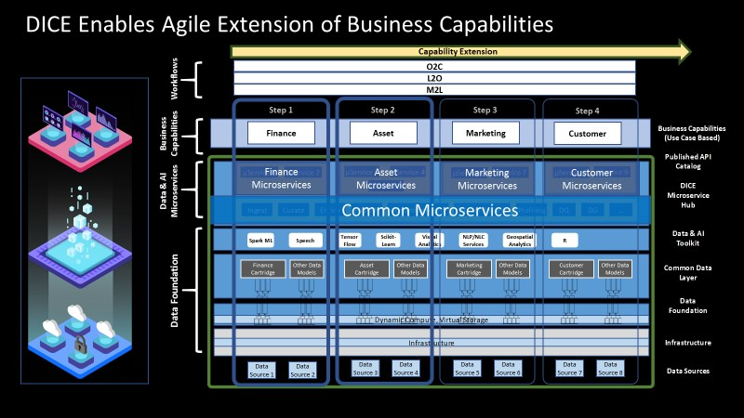

Figure 7 Extension of Business Capabilities via the Data Foundation

## Need for DICE Reference Architecture

Sec. 3.2 describes a data driven cognitive enterprise architecture whereas Sec. 3.3 outlines an “as a Service” offering that leverages this architecture.

As all the challenges and pain points (Sec. 3.1) aggravated over time, we think it is imperative to define a DICE reference architecture to enable the DICE platform and address the emerging clients’ demands. Using this reference architecture as a blueprint, we can define a roadmap to guide the clients to achieve Data Value Transformation.

# Journey to Data, AI and Cloud

## Business Value Propositions with Data Journey

The business value propositions with data capacity/maturity levels enabled by the proposed reference architecture are described in Figure 8. The left column in the diagram describes the capability level of the Data Platform whereas the right column describes the corresponding business value propositions.

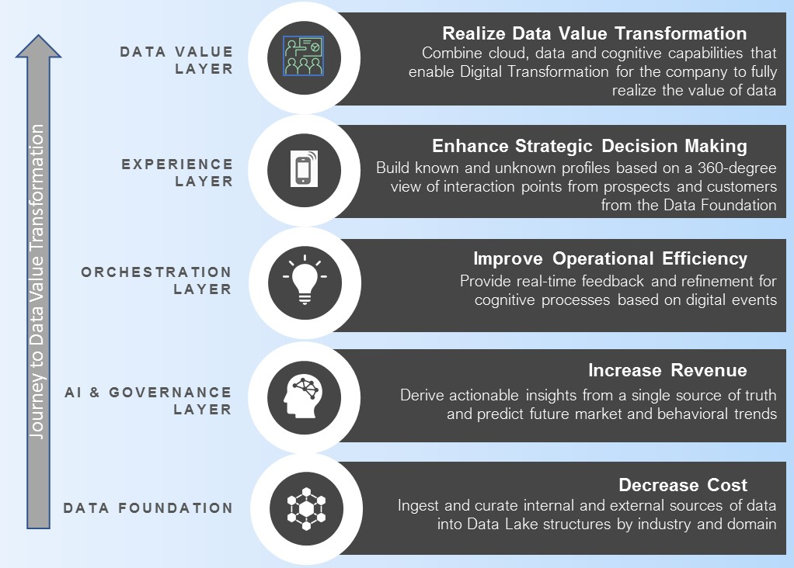

Figure Journey to Data Value Transformation through the maturity of a Data Platform

The diagram also represents a step-by-step journey (from bottom to top) to the ultimate target, i.e., a full Data Value Transformation (DVT.) The DVT, similar to Digital Transformation, represents company’s operational capabilities with people, process, platform and data fully aligned with the business objectives, strategy, and culture of the company.

The maturity of each layer depends on the maturity of the underlying layers. The client needs to ensure the maturity of each layer to advance to the next layer in the transformation process. More importantly, the client can achieve business values at each step of the way through the journey.

Table 1 maps the DVT Journey layers to the DICE layers to illustrate how DICE can guide the clients through the Journey.

Table DICE layers mapped to Journey to Data Value Transformation

|  |  |  |
| --- | --- | --- |
| **Data Journey** | **Established DICE Layers**  **to Achieve Business Value** | **Business Value Prop** |
| **Data Foundation** | Data Sources /Cloud Native Infrastructure /Data Foundation | Cost Reduction |
| **Cognitive & Governance Layer** | + Data & AI Toolkit / Microservice Hub /Info Governance | + Revenue Growth |
| **Orchestration Layer** | + Published API Catalog /Applications | + Improved Operational Efficiency |
| **Experience Layer** | + Intelligent Business Workflows | + Enhanced Strategic Decision Making |
| **Data Value Layer** | + Corporate Level Processes | + Full Data Value Transformation |

**Note**: The ‘+’ notation indicates that the layer or the value is inclusive of previous tier(s).

## Solution Prescription

The DVT Journey may be used as a tool to prescribe a suitable business offering for a client. The DICE based solution should be identified based on the current state of the client. The DVT Journey is a roadmap showing the next level of challenges to the client. IBM will prescribe a DICE based offering that matches those challenges.

For example, if a client has already had Data Foundation (Tier 1) running but facing challenges in moving to the next layer in the DVT Journey. A proper business offering would be to guide the client to the next layer of the Journey, i.e., AI and Governance layer, leveraging the capabilities enabled by DICE.

## Combined Journey to Cloud

DICE based platform integrates the Data, AI and Cloud capabilities, therefore, can serve as a vehicle to guide our clients through a combined journey to Data, AI and Cloud, as illustrated in Figure 9.

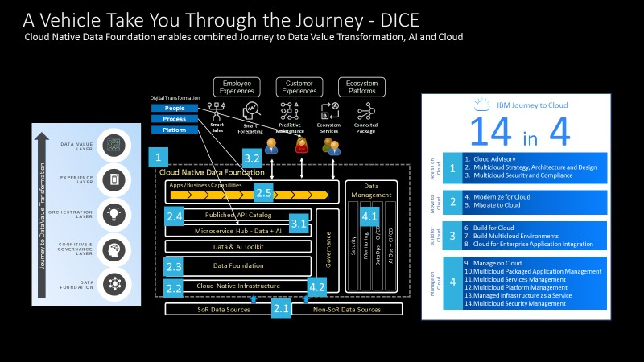

Figure Combined Journey to Data, AI and Cloud with DICE as a vehicle

IBM Journey to Cloud consists of 14 offerings in 4 steps (themes.) The table below outlines high-level activities associated with the DICE layers for the step numbers marked on the diagram.

Table Cloud transformation activities on DICE

|  |  |  |  |
| --- | --- | --- | --- |
| **Journey to Cloud** | **Step** | **Activity** | **DICE Layer** |
| **Advice on Cloud** | 1 | Define Solution Architecture, Data Strategy and Cloud App Modernization Strategy, including Security and Compliance | All layers |
| **Move to Cloud** | 2.1 | Establish migration plan for existing data sources and acquisition plan for new sources | Data Source |
| **Move to Cloud** | 2.2 | Set up K8s based CaaS, DataOps /AIOps CI/CD pipeline and the processes | Cloud Native Infrastructure |
| **Move to Cloud** | 2.3 | Move historical data from legacy system to cloud and set up ongoing ingestion pipelines (batch and streaming) | Data Foundation |
| **Move to Cloud** | 2.4 | Migration of backend services for the application | Published API Catalog  Microservice Hub |
| **Move to Cloud** | 2.5 | Modernization of web applications | Application |
| **Build for Cloud** | 3.1 | Build new microservices powered with Data or AI capabilities or orchestration logic | Microservice Hub |
| **Build for Cloud** | 3.2 | Build new applications that leverage the functionality enabled by new microservices | Application |
| **Manage on Cloud** | 4.1 | Data Management Service (DMS) support security, monitoring, Data/AI Ops and | Data Management Service |
| **Manage on Cloud** | 4.2 | Cloud Service Provider maintains the Cloud Native Infrastructure (IaaS + CaaS) and PaaS (depending on the client requirements) | Data Management Service |

# Architecture Principles

The DICE reference architecture integrates capabilities of Data, AI and Cloud to address a wide spectrum of business use cases. It is worth to note that this is a value proposition, not a technology proposition. In other words, the technologies will be selected largely based on the business needs including the client’s preferences.

To carry out the architecture detail, we start with a set of architecture principles, as shown in Figure 10. These architecture principles are defined to address most recent common business requirements from our clients.

At the center of the architecture, AI and container based microservices are inherent capabilities. Centered around these capabilities, we list 10 architecture principles that should address the clients’ business challenges as described in Sec. 3.1:

* Open Source Based
* to provide a cost-effective solution to avoid expensive licensing fees
* Single Version of Truth
* to provide data from one single version/source so that the business organizations are viewing the same data
* Cloud Technology Agnostic
* to provide flexibility in selecting cloud service provider
* Hybrid Cloud and Multi-Cloud Enabled
* to integrate with best in breed software technologies
* Fit for Purpose Polyglot Storage
* Technology selected to address the SLA requirements from the applications
* Apps and Data Decoupled
* to avoid lock-in to a specific vendor’s technology
* Security in All Layers
* to ensure regulatory compliance and the protection of data
* Compute and Storage Decoupled
* to support flexibility in resource utilization and cost-effective data storage and accessibility leveraging the virtualization technology
* Business Alignment and Audit Readiness
* to govern data usages, quality and processes as well as to align business capabilities leveraging latest data governance technology
* DataOps and AIOps to enable Continuous Integration (CI) and Continuous Deployment (CD)
* to allow the company to continuously improve the features and the quality leveraging the automated processes

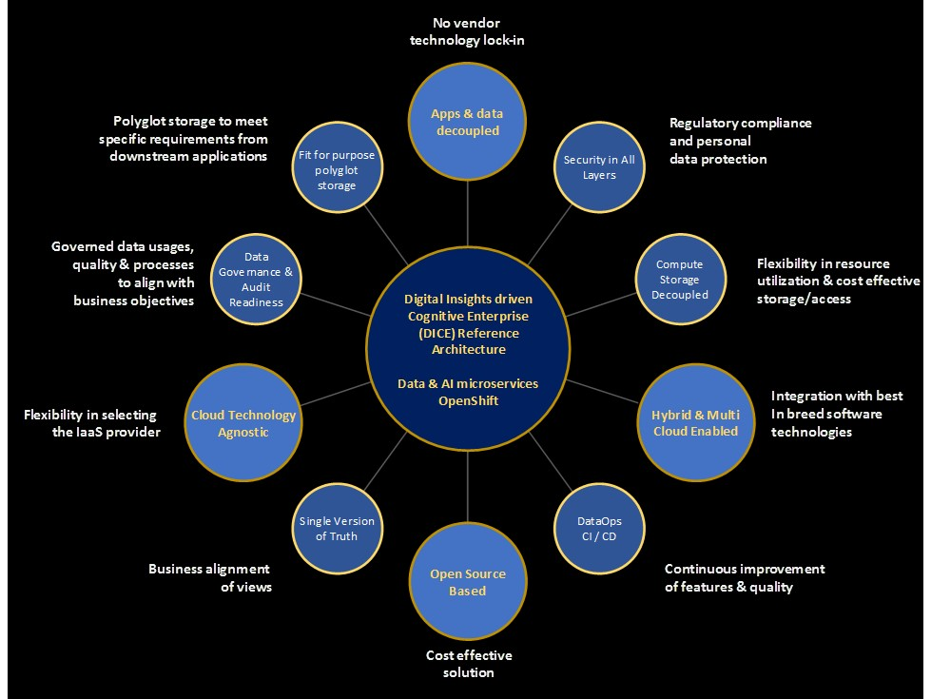

Figure DICE Architecture Principles

# Reference Architecture

## Overview

### Functional Blocks

Figure 11 shows next level of functional blocks in each DICE layer.

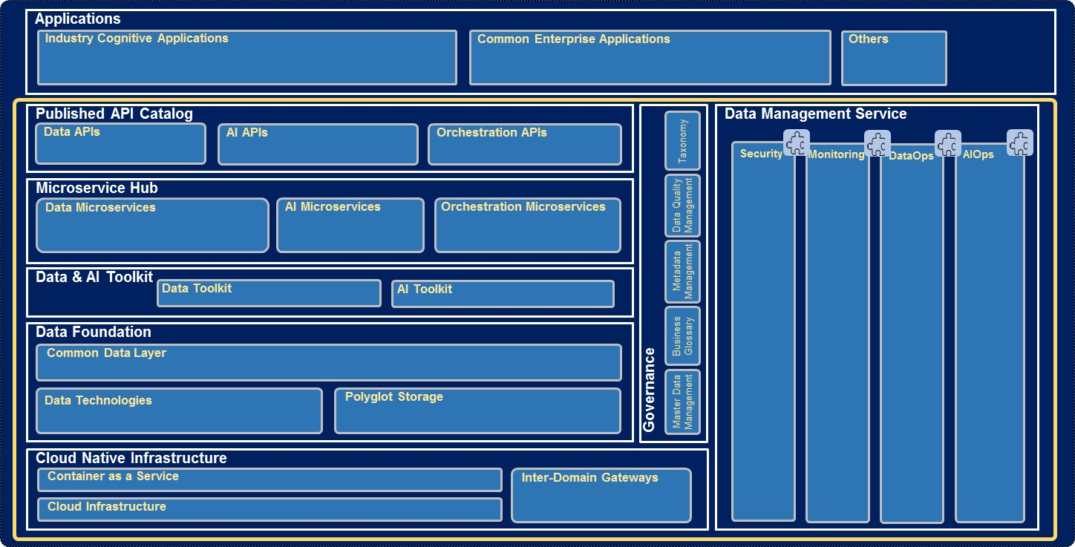

Figure intermediate functional blocks in each DICE layer

### Component Architecture

Moving down to the next level of detail, Figure 12 shows the functional components in each DICE layer and functional block.

These functional components in each of the DICE layers will be elaborated in the later sections.

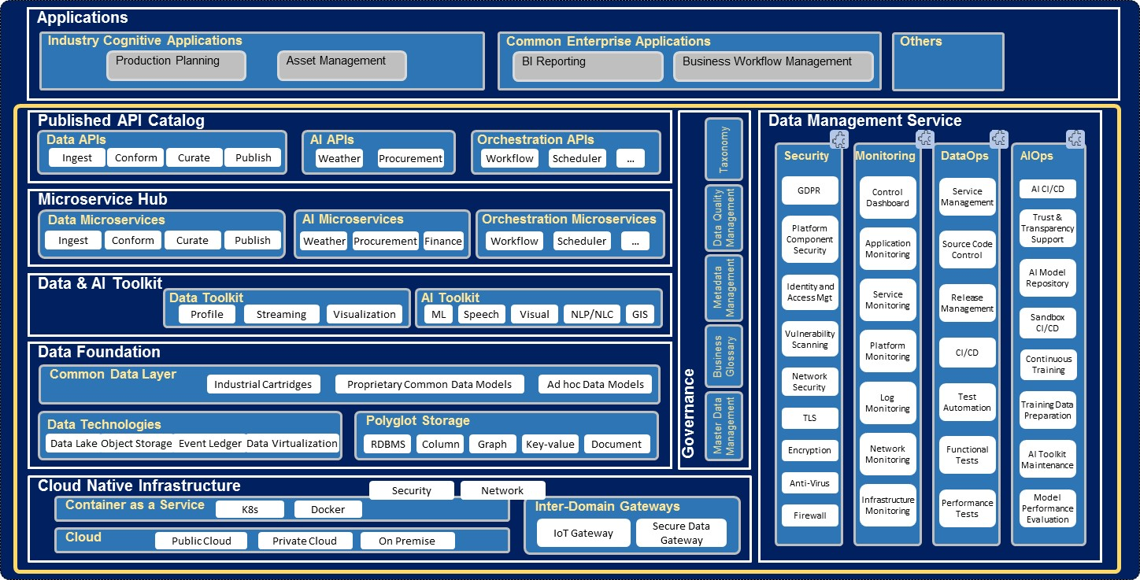

Figure Digital Insights driven Cognitive Enterprise (DICE) Reference Architecture

## Cloud Environment

With the support for container technologies and the architecture principles of “*Hybrid Cloud and Multi-Cloud Enabled*” and “*Cloud Agnostic*”, DICE provides a Cloud Native environment where microservices can be deployed to enable required application features. The REST APIs exposed to the application layer are not restricted to the local microservices (i.e., in an on-premise or private cloud environment).

In the Hybrid Cloud and Multi-Cloud environment, an application can be located in any cloud or location. More importantly, the client has the flexibility in adopting *the best in breed* services available from any cloud for its applications.

This section discusses the implications and the challenges with the cloud environment.

### Container based Environment

#### Open-Source Kubernetes

Kubernetes and Docker are selected as the default container technologies for DICE to enable the Cloud Native environment. Docker offers OS level virtualization that enables delivery of software inside standardized software packages called *containers*, whereas Kubernetes is an open-source container orchestration tool that provides the following features:

* Intelligent Scheduling
* Service discovery & load balancing
* Self-healing
* Automated rollouts and rollbacks of containers
* Automated horizontal scaling
* Secret and configuration management

Kubernetes and Docker are by far the most popular container technologies used by Cloud Service Providers. The two offers a robust, highly scalable and automatable foundation for the platform.

#### Red Hat OpenShift

The DICE platform may also leverage OpenShift supported on Red Hat Enterprise Linux as an enhanced Kubernetes environment. OpenShift supports following features:

* Kubernetes based
* One-click setup and push-button upgrades
* Simple “git push” for deployment of applications from source code
* Consistent foundation for Hybrid Cloud workloads – enhanced visibility in viewing and managing all the clusters
* Features for development lifecycle management:
  + standardized workflow,
  + support for multiple environments,
  + Continuous Integration,
  + release management etc

The Continuous Integration and Continuous Deployment (CI/CD) pipeline for DataOps and AIOps may leverage the development lifecycle management support from OpenShift. With OpenShift, it will also become easy in setting up, managing or upgrading the Kubernetes clusters.

### End-to-End Data Flows

Figure 13 illustrates how the DICE components work coherently to enable an end-to-end application data flows. The bottom layer, Data Foundation, acquires the data from a number of sources, ingests the data into the data lake, curates the data and publishes the data to the DICE Microservice Hub or the Application layer.

In parallel, the Data Foundation also collects and stores the technical metadata, e.g., data lineage, and business metadata, e.g., business glossary into the Data Governance Repository. These metadata can be processed with AI models to generate outcomes that may be used to automate or improve the data governance/management processes.

In the top layer, i.e., the Application layer (a.k.a., Business Capability), may be composed of a backend server with frontend UI apps (Mobile and Web app) where the backend server implements the required business logic that leverages the AI outcomes coming from the microservices via the internal and/or external REST APIs.

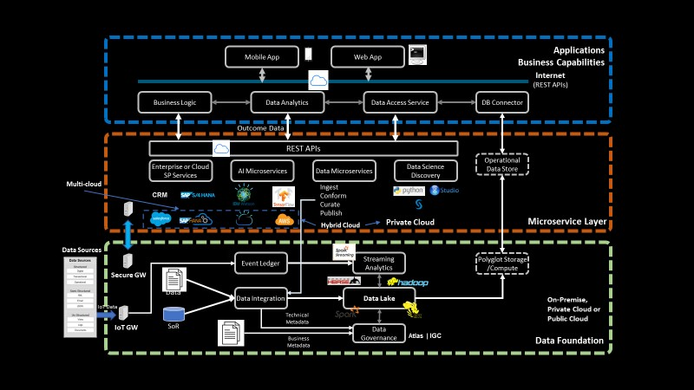

Figure DICE E2E Application Data Flow - Illustration

#### Data Sources in a Hybrid Cloud environment

Data in a multi-cloud or a hybrid cloud environment may come through these protocol-enabled interfaces:

* sFTP
* REST API
* Database Connectors
* IoT Data Transfer (MQTT or HTTPS)

from these domains

* Data Centers
* On-Premise
* IoT Edge devices

via following gateway services:

* Secure Data Gateway
* Application Server
* IoT Gateway/Hub

The data sourcing patterns in the CI-CE cloud environment are illustrated in Figure 14.

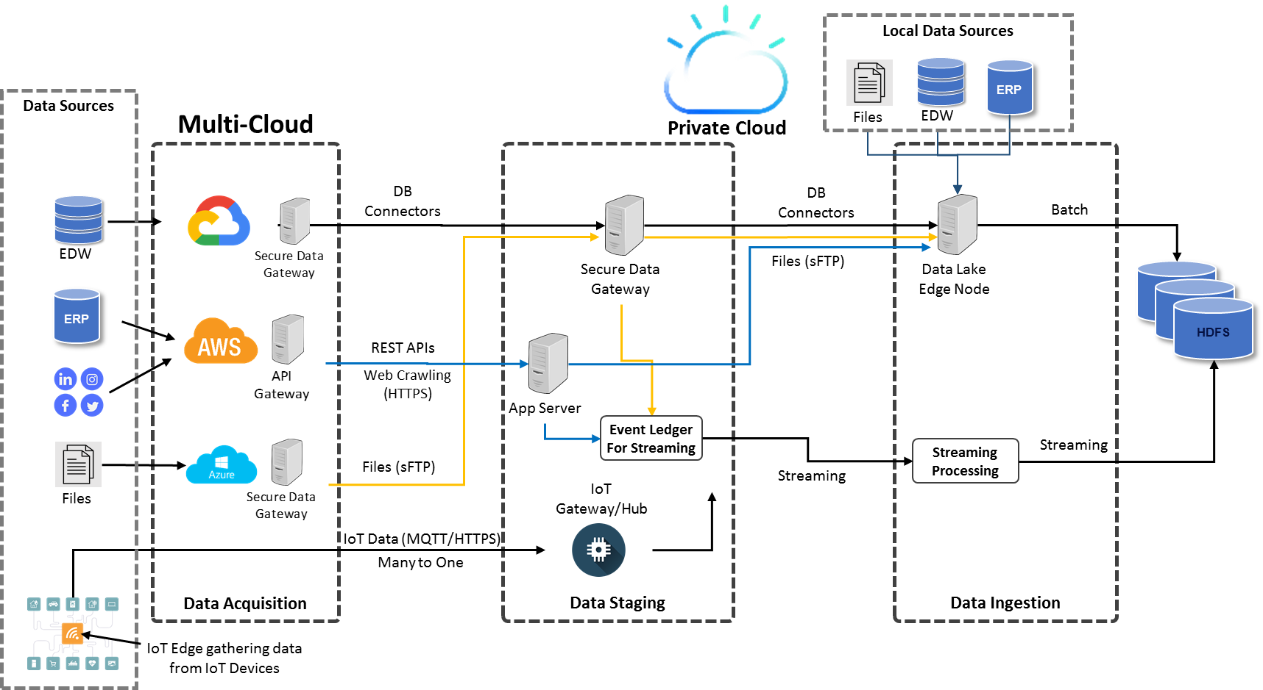

Figure Data Sourcing Patterns in the DICE Hybrid Cloud environment - Illustration

As shown, the data sourcing in a hybrid cloud environment could be quite complex where the required data sources may be located anywhere. From Data Foundation’s perspective, raw data should always be available via Edge Node of Hadoop or Kafka. However, the data staging area may be located on one of the three or more appliances:

* Secure Data Gateway
* Application Server that runs the backend applications and likely located in the K8s cluster
* IoT Gateway or Hub where data from IoT devices are collected

#### Data Movement

Data movement between any two domains (e.g., two Data Centers or IoT Edge and Data Center) is costly in terms of latency and money. Therefore, the design of a data pipeline needs to be carefully thought through in a hybrid cloud or multi-cloud environment. A general rule of thumb is to avoid the data movement unless it is necessary. Therefore, it is not recommended that the data zones (Raw, Conformed and User/Enriched) in a data lake be distributed across multiple clouds since data moving across these zones is normally in large volume.

#### Data Fabric

Data Fabric in the hybrid cloud environment may integrate with Master Data Management (MDM) available from the public cloud. For example, the client may leverage the CRM service from SalesForce to transfer the Customer data leveraging the Master Data and Reference Data to integrate the data on the DICE platform.

In Data Fabric, complex integration patterns such as streaming data integration with the analytics outcomes from a public cloud may also be required by some use cases. Latency analysis for End-to-End pipelines need to be performed to ensure that the solution addresses the SLA required by the use cases.

#### Data Consume

The data flows in and out through the APIs should be small volumes of data. For a large volume of data, the application should leverage the secure data gateway to move the data.

Even if the applications and the dependent microservices have small volume of data exchanged through the REST API calls, the best practice for designing an application or microservice is to always minimize the network traffic for application data flows by adopting a design principle in analogy to “predicate pushdown” for data queries or acquisitions.

### Microservice and API Framework

#### Microservice Environment

We choose Spring Boot as the default microservice environment to develop and deploy the DICE microservices. Spring Boot helps build quickly production-ready applications and provides following features

* Web Development
* SpringApplication
* Application Events and Listeners
* Admin features
* Eternalized configuration
* Properties files
* YAML support
* Type-safe configuration
* Logging
* Security

Figure 15 illustrates the Web Service architecture in Spring Boot.

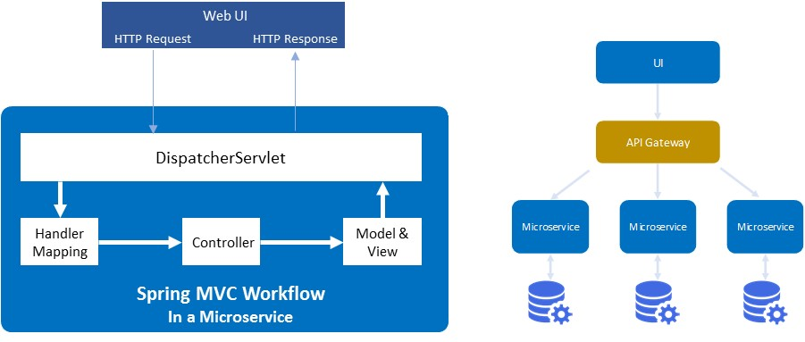

Figure Default Microservice Framework - Spring Boot

#### API Framework

We choose Spring Cloud as the default ecosystem for the API framework. Only a subset of the Spring Cloud components is used to complement the existing Kubernetes features. These components include

* Zuul API Gateway

Zuul is a single-entry point for accessing microservices, it provides dynamic routing, monitoring resilience, security and more

* Eureka

Eureka is a REST (Representational State Transfer) API based service that is primarily used for locating other REST API services via registration and discovery

* Configuration Service
* Authentication Service

### Challenges to Clients

In a Hybrid and Multi-Cloud environment, the data landscape is greatly extended. The main challenges with this environment are in the areas of security, data governance and data management, for example, tracking the end-to-end data lineage to ensure the accountability of the business owners or assurance of the security compliance.

No out-of-box tool currently exists in overlooking the security or data governance/management across multiple clouds or domains. Therefore, customized assets to manage the data based on client’s data landscape should be designed with the considerations of security and data governance. In this regard, OpenShift provides enhanced visibility in viewing and managing all the Kubernetes clusters across clouds.

The design may sometimes have to trade certain hybrid cloud features for security compliance when high security risks are identified in the public clouds.

## Data Foundation

The Data Foundation combined with Data and AI Toolkits is equivalent to Digital Insights architecture as shown in Figure 16. For the detail of the Digital Insights reference architecture or its component functionality, please refer to *GBS Digital Insights White Paper v1.6*.

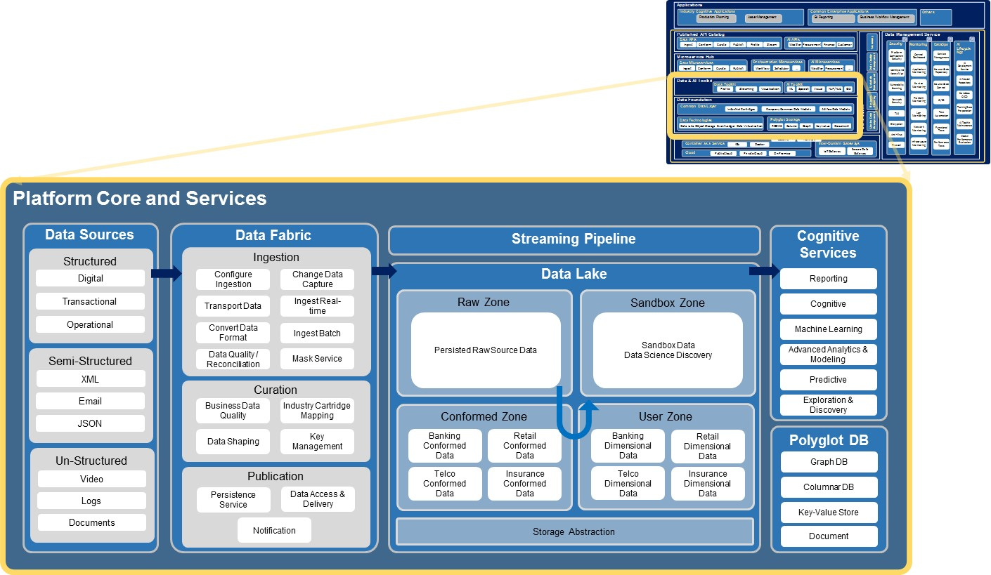

Figure Data Fabric and Services - Digital Insights

We highlight here the key practices that will help establish a successful Digital Insights platform. These key practices include

* Data Lake as Single Version of Truth
* Common Data Layer that leverages Industry Data Model as an accelerator
* Master Data Management to ensure the quality of data integration
* Data Governance – Data Quality Management and Data Lineage

These four practices should be incorporated as design principles when implementing the DICE Data Foundation.

## Published API Catalog

The Published API Catalog layer, enabled by REST APIs (Application Programming Interfaces) of the Microservices, is a logical layer that provides an application runtime environment which enables most of the application features.

APIs expose to the applications the locally published Microservices. This layer supports three major categories of APIs related directly to the application functionality:

* Data APIs
* AI APIs
* Orchestration APIs

Each API may work with a group of underlying microservices (associated with either published or unpublished APIs).

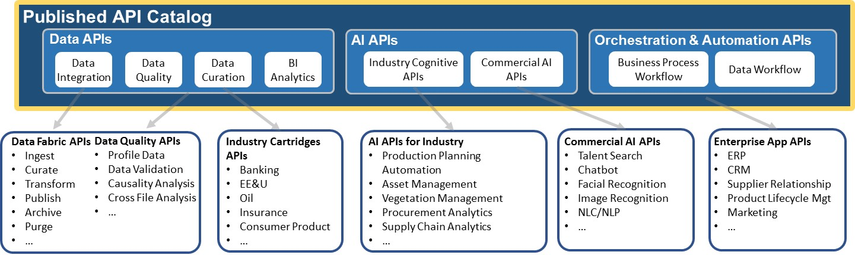

Figure Examples of APIs

## DICE Microservice Hub

DICE Microservice Hub contains microservices that may or may not be published. Some of the microservices may only be used as internal APIs, so is not accessible from Internet via the API Gateway.

Figure 18 shows three main categories of microservices that has one to one mapping to the API layer:

* Data Microservices
  + Data Microservices include software libraries/functions that integrate the data through ingest, conform, curate and publish processes or help analyse the characteristics of the data.
* AI Microservices
  + AI Microservices encapsulates the productionized AI models (descriptive, diagnostic, predictive or prescriptive) that leverage the Data & AI toolkits such as R-Studio or Machine Learning /Deep Learning libraries.
* Orchestration Microservices
  + Orchestration Microservices implements the logic to automate and orchestrate multiple processes.

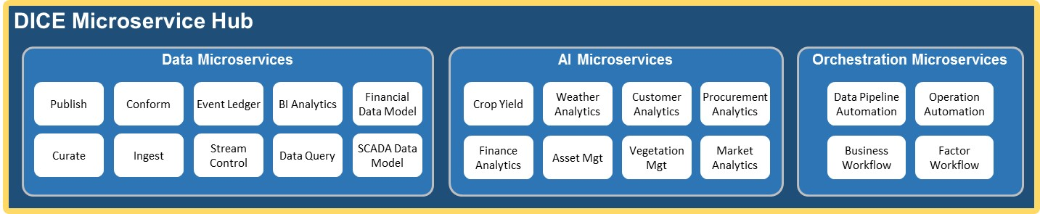

Figure Examples of Data and AI Microservices

## Data and AI Toolkit

The Data and AI Toolkit layer contains libraries or cloud services that support various data and AI development toolkits including Machine Learning, Neural Network libraries, Blockchain and data integration and quality tools and etc.

Figure 19 shows an example of the layer.

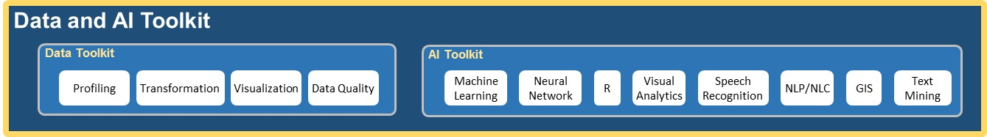

Figure Illustration of Data and AI Toolkit Layer

## Data Governance

The Data Governance layer in DICE orchestrates people and technologies around well-defined processes to enable an organization to leverage data as an enterprise asset.

The layer captures and stores the technical/operational metadata as well as business metadata. As shown in Figure 20, the layer supports functionality including Master Data Management (MDM), Metadata Management, Data Quality Management, Business Glossary, Ontology and Taxonomy.

In addition to the technical functionality, DICE also defines roles, responsibilities and processes for a default Data Governance program.

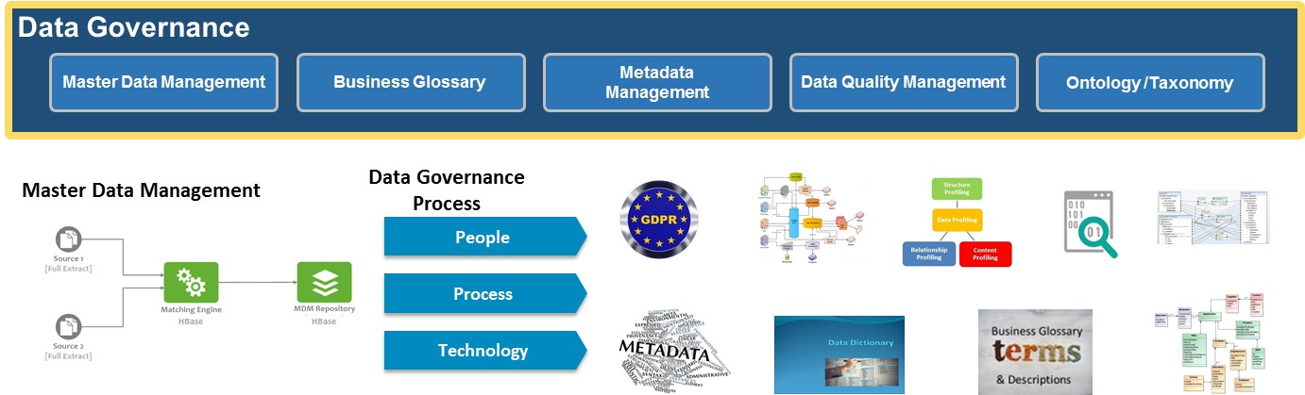

Figure Illustration of Data Governance Elements

For metadata management, the Governance layer interacts with multiple layers to capture technical or operational metadata in the following areas:

* Data lineage
* Data quality
* Data profile

Currently, there has been initiatives for developing business corpus-based analytics or metadata analytics. The assets resulting from these developments will help automate the Data Governance processes or help gain deeper business insights.

## Data Management Service

As shown in Figure 21, Data Management Service (DMS) in DICE consist of three categories:

* Security
* Monitoring
* DataOps
* AIOps

Data Management Service plays a pivotal role for making an “as a Service” offering. Each Cloud Service Provider has its own SLAs and practices. DICE DMS is able to bridge the gap between a specific CSP’s SLA and the client’s requirement.

DMS provides DevOps, DataOps and AIOps to continuously improve the microservice features, data features/quality and the performance of the AI models.

DMS maintains the security measures including the GDPR practice, as well as monitors the security, platform performance and stability.

DMS will also help with the audits by tracking the periodic system reports and other required information.

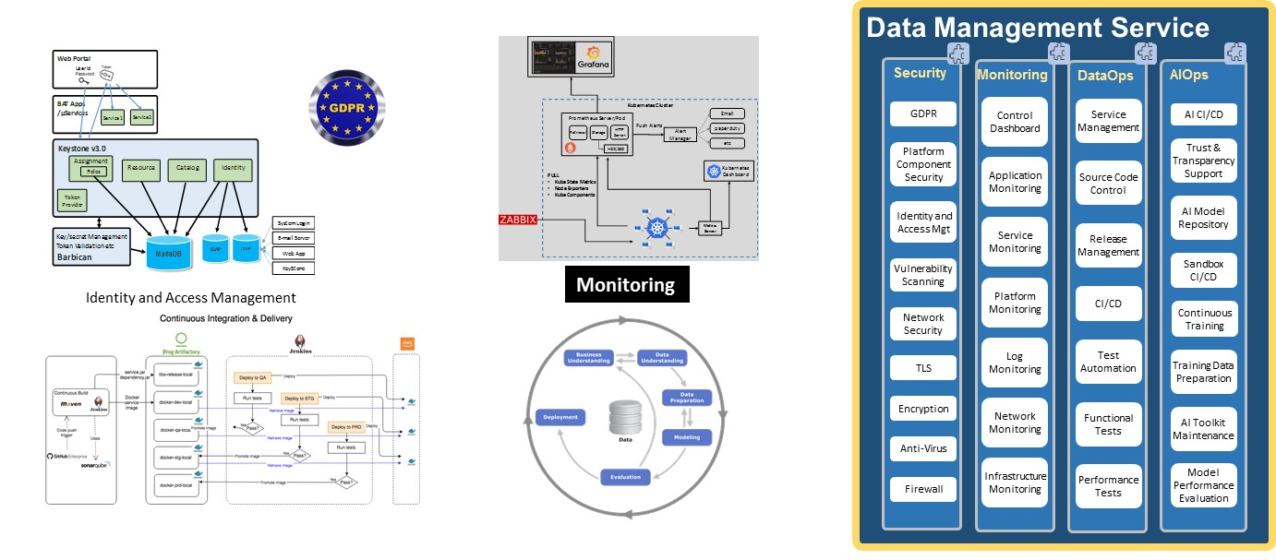

Figure Illustration of Data Management Service

## Cloud Native Infrastructure

Cloud Native Infrastructure consists of Infrastructure as a Service (IaaS) and Container as a Service (CaaS) where CaaS provides a cloud native environment to the applications. The CaaS is based on the Kubernetes and Docker container technologies.

Because of the CaaS, DICE is cloud agnostic, i.e., it can be built in an on-premise environment or on any of the following cloud types

* Public Cloud – a cloud managed by a Cloud Service Provider and the infrastructure is available to public
* Private Cloud – a cloud where the client manages its own operations or via 3rd party service provider (e.g., IBM GBS) and the infrastructure is only available to a company or an organization
* Dedicated Cloud – a private cloud where its infrastructure consists of dedicated hardware and is completely isolated from other cloud tenants

As mentioned earlier, the infrastructure also supports two types of gateways to quickly move data from and to different domains including IoT domains and 3rd party clouds.

# Architecture Principles Explained

In this section, we want to clarify or elaborate on some of the Architecture Principles described in Sec. 4 so that the value propositions from the DICE is clear.

## Data and Application Decoupled

This architecture principle not only prevents lock-in to a specific vendor technology, but also expand the application use cases. For example, the data in an Enterprise Data Warehouse traditionally is used only business reporting. The decoupled data can then be used by data science discovery to identify more business insights which in turn can be used by many applications.

## Open Source Based

This architecture principle does not require all the components in a solution to be open sourced. As mentioned, the technologies will be selected based on the business requirements, although an open source technology may be selected initially as preferred one by default.

## Single Version of Truth

It is always a challenge in setting up the Data Lake as a Single Version of Truth (SVOT). Without SVOT established, business organizations may access the same table from different sources where the data may be inconsistent.

By this architecture principle, all the data should be integrated into the data lake and subsequently subsets of the integrated data are extracted and used by the downstream entities. In a lambda architecture, the implementation needs to ensure that the SVOT is still maintained, i.e., the data is in sync while the streaming pipeline (the fast path) bypasses the Data Lake.

## Fit for Purpose Polyglot Storage

Polyglot Data Store is a data store to be selected to bridge the gap between the client’s requirements and the Data Lake capability. The selection criteria for a Polyglot Data Store is largely based on the requirements from the view of the CAP theorem, multiple region support and the performance/latency gap. For example, Cassandra may be used to address the requirements for High Availability (HA) and support for multiple regions.

Multiple Polyglot Data Stores may be used in the DICE platform to address requirements from different applications.

## Cloud Agnostic

DICE is based on popular container technologies, Docker and Kubernetes, so is a Cloud Native approach. Other than the infrastructure, the DICE based platform should not be based on the technology specific to any Cloud Service Provider. The build team should abide by the following guidelines to avoid unnecessary issues:

* Keep microservice stateless as much as possible
* Unless has been proven extremely stable, Cluster based data repository should be left outside of the K8s cluster as each database node is not stateless

The “Cloud Agnostic” architecture principle should not be applied to the client’s architecture since the client may select one single cloud to host the platform and applications.

# Component Business Model

Figure 22 shows the IBM Component Business Model (CBM) for DICE Transformation, which highlights the associated business processes/activities used to achieve the Transformation.

The cell in the top row represents the business capabilities or organizations related to the DICE Transformation whereas the left most column represents the lifecycle of business activities – Directing, Controlling and Executing. The model can be used to analyze the alignment of enterprise strategy with the organization’s capabilities and investments.

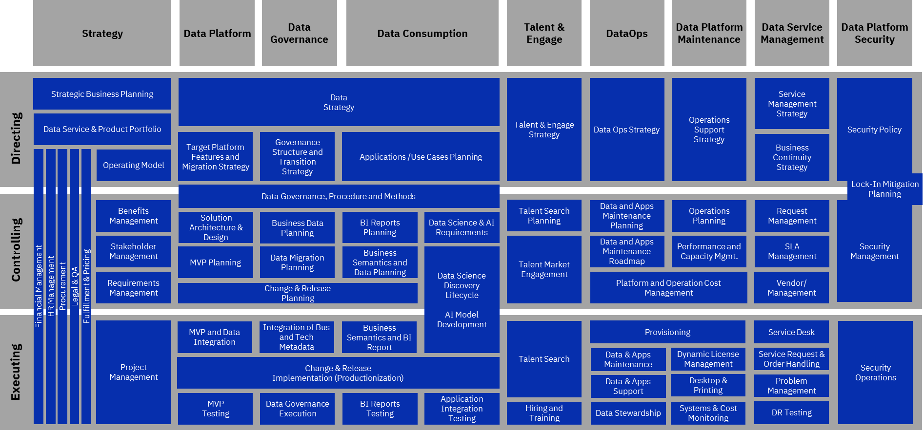

Figure 22 Component Business Model for DICE Transformation

# Use Cases

The business benefits of DICE reference architecture can be best demonstrated via the use cases based on the real client requirements.

## S/4HANA and EDW Transformation

Companies using SAP ERP software have found themselves in a dilemma where they were forced either to migrate to S/4HANA or continue using the same SAP software with limited support starting from 2025.

SAP ERP was designed to be a transaction-based application with data deeply coupled with the application. If pursuing the upgrade path, the companies lock themselves to the same technology that are costly and not designed to scale.

The transformation consists of two parts (see Figure 23):

* Data Fabric
  + Can be fully transformed
* Compute (App compute offloading)
  + Partially transformed

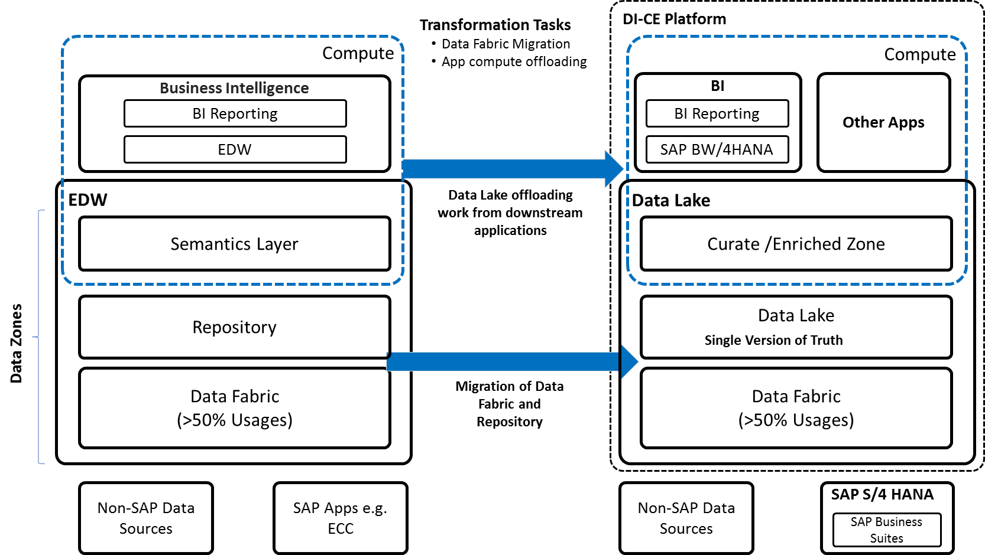

Figure S4/HANA Transformation

The steps of S4/HANA transformation are outlined in the following diagram:

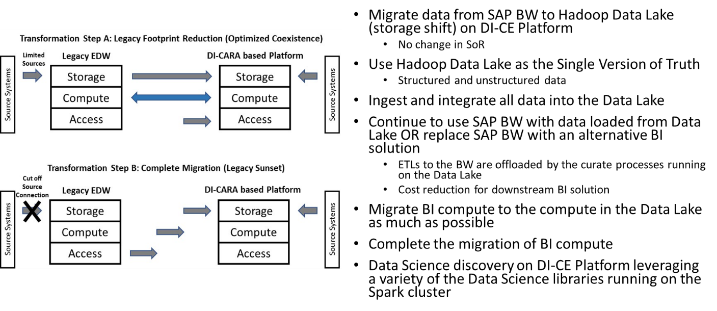

Figure Illustration of S4/HANA Transformation Steps

DICE provides a solution and a migration plan with the following benefits to the clients, compared with other solutions,

* Low cost compared with migration to the same technology, e.g., SAP S/4HANA
* Options in selecting the best technologies available from clouds
* Options in choosing the cloud service provider for hosting the platform
* Highly customizable by building microservices to fill in the gaps for automation or integration
* Flexibility in choosing from various analytics capabilities, from Apache Spark, TensorFlow to IBM Industrial Data Catalogs or Out-of-box Watson Analytics

## Intelligent Business Workflow

DICE may also be used to enable individual business workflows, as illustrated in Figure 25.

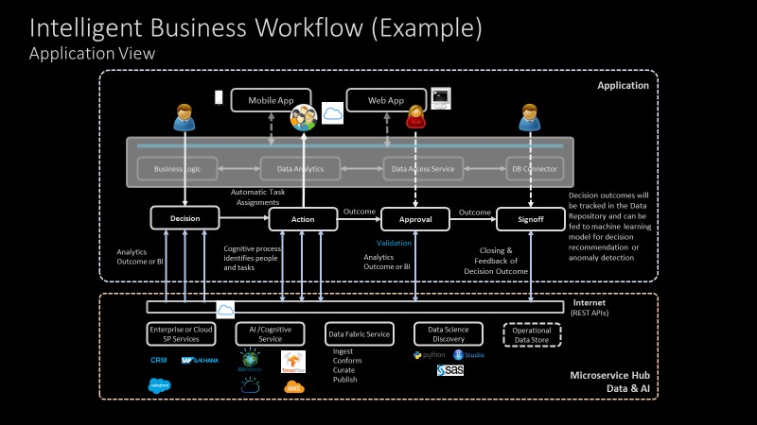

Figure Illustration of Business Workflow Management with DICE

Figure 25 shows a business workflow from Decision, Action, and Approval to Signoff. Each step may be triggered by the detection of changes using Artificial Intelligence (AI), for example, running from a fraud or anomaly detection engine.

As illustrated, a message is sent to the department head to decide if actions need to be taken in the case of a possible fraud. If actions are approved, the platform with the AI capability dispatches the tasks to a group of individuals who AI identifies responsible for executing the tasks.

Upon the completion of all the tasks, the platform may validate the status then send the outcome of the executed action to the decision owner for approval. The history of the workflow and the outcome can be tracked in the platform and fed to a Machine Learning predictive model to train or update the model. The predictive model may be used next time, for similar cases, to recommend an action for the manager or detecting if the decision may deviate from the normal decision.

This use case illustrates how a client may use the DICE platform to manage a business workflow with AI capability. The use case may also leverage the Blockchain technology to securely track the workflow.

DICE may help accelerate the process of developing Cognitive Workflow Management by providing an application framework that help integrate the AI process with workflows.

## Cognitive Integration Hub

For the sports and entertainment industry, event deliveries, fan engagement, customer journey, and merchandise sales are important business components and need to be integrated to allow the organization to operate consistently and seamlessly.

DICE provides a solution (see Figure 26) that integrates both data and applications/processes and provides the capabilities for development of AI enabled applications. The benefits of the offering are

* End-to-End solution from Data Fabric, Services to Applications
* Avoidance of re-inventing the wheel - leveraging the CRM and other marketing services from SalesForce
* The client can exploit the analytics capabilities by building new microservices for the fan engagement or customer journey activities wherein new revenue opportunities can be identified

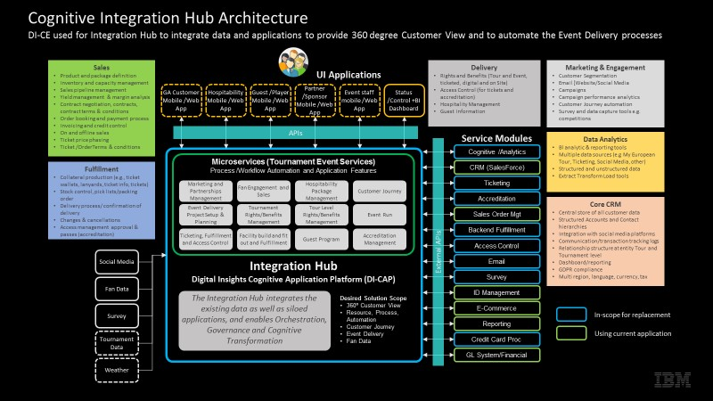

Figure Integration Hub for a Sports Tournament Association

# Digital Insights Method

To help our clients with Data Value Transformation, we offer the Digital Insights Method framework for execution.

Figure 27 describes the overall framework of Digital Insights Method (DataFirst approach) whereas Figure 28 describes the logical timeline for executing the Digital Insights Method.

For detail of Digital Insights Method, please refer to this link to IBM Digital Insights Method (CBDS 2017).

The framework is a key differentiator of the IBM Cloud and Analytics business where the IBM focus and execution on helping clients get the most value from their data.

Regardless of the workload or solution – across analytics, app development, and AI – the use and application of data is the common driver to providing the desired value and outcome.

The method can be embraced from an architecture domain for solution design and also an engagement model.

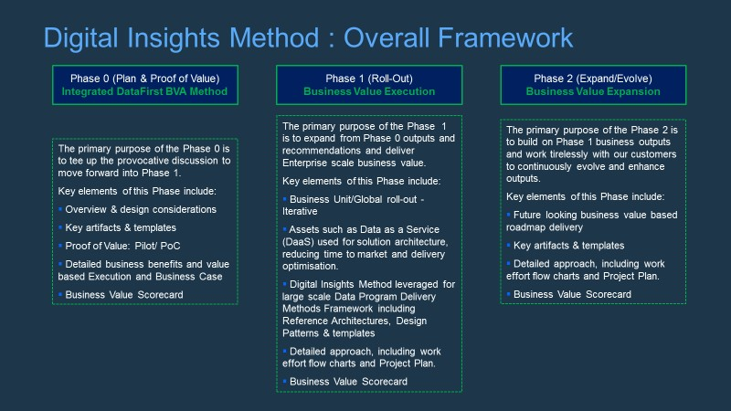

Figure Overall Framework of Digital Insights Method

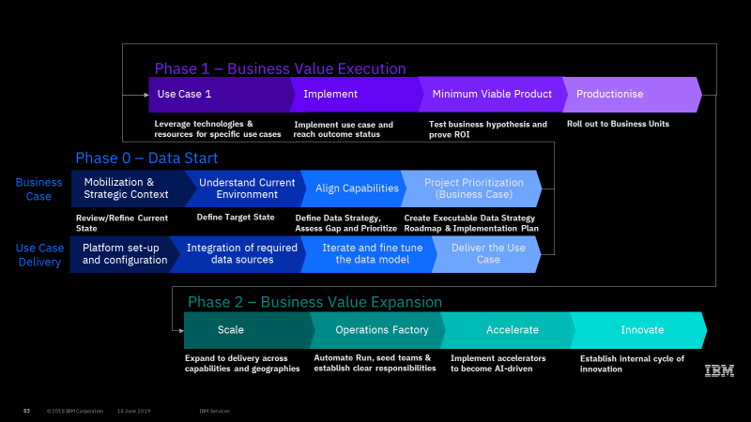

Figure Logical timelines for executing Digital Insight Method

# Conclusion

DICE is not considered technically disruptive. The architecture extends the horizons of a data platform to cover an end-to-end Cognitive Enterprise scope. From the technical standpoint, the design based on DICE for supporting data consumption, either high-level or detailed, can be highly aligned with the use cases because of the inclusion of microservices and applications, which help create end-to-end data consumption pipelines.

From the business standpoint, DICE provides flexibility in making offerings to IBM clients as the application space adds a new dimension. DICE helps build storyboards with a clear end-to-end view and rationales so that the architects or sales can efficiently and effectively communicate with the clients about the IBM offering.

# References

(Foster 2019) The Cognitive Enterprise: Reinventing your company with AI, Mark Foster, IBM Services and Global Business Services, January 28, 2019

(Research 2018) Creating a Data-Driven Culture Is the Latest Trend in the Business Intelligence Market, BARC Research, November 6, 2018

<http://barc-research.com/data-driven-culture-is-latest-bi-trend/>

(Mike Rollings 2018) Build a Data-Driven Enterprise, Gartner Data & Analytics Summit 2019, Mike Rollings and Andrew White, August 8, 2018

<https://emtemp.gcom.cloud/ngw/eventassets/common/research-notes/documents/gartner-research-data-driven-enterprise-2019.pdf>

(Service 2019) GBS Digital Insights White Paper v1.6, Data Platform Service, Cognitive Business Decision Support, IBM GBS, February 21, 2019

<https://ibm.box.com/s/ee01vdl51sigweu0qzfuwnrxd80xknxt>

(CBDS 2017) IBM Digital Insights Method – Taking DataFirst Approach, Data Platform Service, Cognitive Business Decision Support, IBM GBS, September 18, 2017

<https://ibm.ent.box.com/file/197202226455>